Dr. Zdeněk Kalvach, CSc.
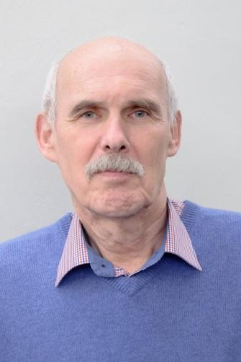
Dr. Zdeněk Kalvach is a mastered czech doctor, pathfinder of modern geriatrics and gerontology. He has written several geriatric textbooks and almost one hundred professional and popularised articles dealing with health and existentialist themes. He lectures on expert forums, on the Faculty of Arts and on Evangelical Theological Faculty of Charles University. He is a member of the Ethics Committee ČLK and he cooperates with the office of Public right protections. He was a member of the Government Council for elderly and senescent population and a deputy minister for human rights.

EAN Medical Diagnosis and Detection

Medical diagnosis and detection of elder abuse and neglect elderly people, not appropriate treatment of elderly people in general, especially of those who are less self-reliant or completely reliant, is often a touchy theme and with relationship complications. Apart from that it is often not easily discerned especially if we take its light forms. As it is said in medicine: a woman can not be “a little bit pregnant” (sometimes a little bit pregnant, sometimes not), with EAN it could be like that. If we talk about the cases of EAN, the relationships are complicated, the connections are various, they are ambivalent and it is hard to see into them and try to solve the problem. A practitioner or a doctor who takes care of the patient should have his/her trust so that the patient opens up about the situation by him/herself if he or she wants to solve it. In other cases it is important that the practitioner has the knowledge about EAN so that he/she is ready to be sensitive when the patient talk about “weird” (weirdly placed, weirdly usual or weirdly explained) injuries, about negligence, uncommon behaviour from the patient (evasive, apparent fear of relative, sorrowful crying), about the prime person that the suffering comes from (uncommonly rude or on the other hand uncommonly sweet, be against the fact that the patient is with the doctor alone, playing with the patient’s health by modifying his/her medication). It is important to reflect about the unmenagment of caring. EAN often grows from the situation when there is the exhaustion and quandary of the family, growing family conflicts even in front of the doctor- that only makes EAN stronger. The important thing is to reflect the reality- depressing moods, disrespect to one’s situation, loss of self esteem, fear of not having independence, balancing with the “ending life” which can be a foretaste of suicide. The doctor has to be able to differentiate if the situation is about serious danger of the patient that can’t be suspended (the case is usually solved by replacing the patient to immediate constitutional care for example to the hospital and even filling a criminal complaint) or if the situation is protracted and can’t be solved by criminalization or separation but with the explanation, help with setting an optimal care, psychotherapy, crisis intervention, and control by the public. EAN/EDAN is always a group social issue and it usually does not have an easy solution. It is the same with physical problems that can’t be cured. When the institutional care is present the doctor should heed as much as he/she can that there shouldn’t be any kind of EAN in a sense of individual misdemeanor or in the system concept of care (misuse of restrictive object, overdose with calming psychopharmaca, neglecting the care, humiliating, or induce hospitalization.)

