Prof. Ariela Lowenstein

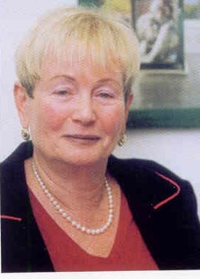
Prof. Emerita Ariela Lowenstein, Dept. of Gerontology & Head Social Gerontology, Center for Research & Study of Aging, University of Haifa Israel.
Lowenstein was a faculty member at the Social Work School acting as assistant Dean. Then in 2000 she established the Graduate Dept. of Gerontology and headed it for the first 5 years, as well as creating the Center for Research & Study of Aging. She was also active at the University at large, serving as a member of the University Senate and heading committees for promotion of faculty members.

She has an MA in Social Work and Public Administration, New York University, US; a PhD in Sociology, Hebrew University, Jerusalem. Always focusing in her work on family intergenerational relations.

After retirement she was enticed to join Max Stern Yezreel Academic College as Head of the Dept. of Health Services Management and 3 years later has been appointed as President of the College and served in this capacity for the next 4 years, between 20012-20016, of the College. She established there and Co-chaired the International Aging Research Center. Later, she returned to the Dept. of Gerontology at Haifa University where she is mentoring PhD and MA students. She is also very active at the Research Center, currently heading the Israeli part of a large European project: GenderNet within the Horizon framework, as well as being a partner of a project on 'Work and Retirement' funded by the Israeli Ministry of Science. Lowenstein is also a partner, representing Israel with a colleague, in 'COST' Network on: 'Reducing old age exclusion in Europe: collaborations in Research and Policy – ROSEnet'.

She publishes extensively in top scientific journals, having more than 250 publications - 2 Hebrew books, and 1 English with a colleague: Generational Intelligence”; Co-editor of several special issues on family intergenerational relations”; co-editor of 3 English books and serves as a reviewer for a number of leading journals on aging like "Research on Aging, also serving as a board member there and other journals. Lowenstein also acts as a reviewer to prestigious research foundations like the ISF and BSF. Recipient of numerous competitive research grants in Israel and abroad; prestigious scholarships, national and international awards.

Lowenstein is reputed as a leading national and international expert in aging, family relations and elder abuse, serving on various international boards like INPEA (International Net Work fighting Elder Abuse and Neglect) with whom she organized last year an event at the United Nations. She is also a member of various advisory committees in Israel and abroad. She is invited as a key-note speaker to many prestigious conferences in Israel and abroad.

Lowenstein is also active in many Educational and Research Organizations on Aging - a fellow of the Gerontological Society of America; was in the past the President of the European Gerontological Society; served for 5 years as President of the Israeli Society of Gerontology and headed a national committee on Aging for the Israeli Pensioners Office. She is a member of the NICE (National Initiative for Care of Elders) at the University of Toronto, heading a group on Elder Abuse.

Research areas: Intergenerational family relations, Caregiving, Elder abuse and neglect; elders' exclusion, policy development; gender issues related to aging.

