MgA. Jan Lorman
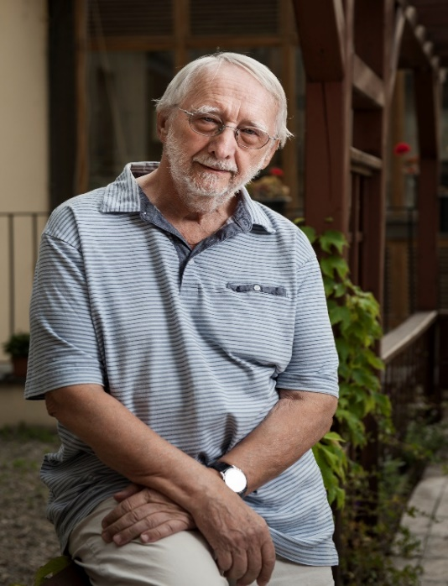
MgA. Jan Lorman is the founder and director of the institution Život 90 ( „Life 90“). Since the year 2011 he has been also the director of the Gerontological Institute. He acted as the President of the Czech Council of Humanitarian Organizations, Vice President of the European Union of Ageing Citizens (EURAG), a member of the Board of International Federation on Ageing (IFA). He is a member of the Government Council for Seniors and Issues on Ageing. He also represents the Czech Republic in the International Network for Prevention of Elder Abuse INPEA. He is the author of the projects „System of Distress Care Areíon“ and „Community Center Elderly People House PORTUS“. He pursues permanently professional and public educational activities both in the Czech Republic and abroad, primarily aiming at the discrimination, cruelty and elder abuse, the services for assisted life, the status of those taking care informally. He urges the human responsibility for life, the need of searching the meaning of life even in the elderly age.

Domestic Violence or EAN?
We have become accustomed to applying the term „domestic violence“ to all situations in which cruelty of one person towards another one comes about. But in fact we forget that violence does not take place at home solely but in residential social and health facilities, in offices and services, as well. This is not the only reason why it is necessary to distinguish between the domestic violence, abuse and cruelty towards elderly citiziens. The deciding factor is their different social status. They are economically dependent, for their essential income is their retirement pension and, with growing age, they need more social services and health care.
Already in the last century both in the United States of America and Great Britain there the Syndrome of an abused, misused and neglected senior had been recognized – Elder Abuse and Neglect (EAN) – the topic debated at the World Convention on Ageing in the year 2002.
Our aim must be to implement this broad concept of elder abuse beyond the borders of the Czech Republic.

