MUDr. Ilona Divácká, MBA
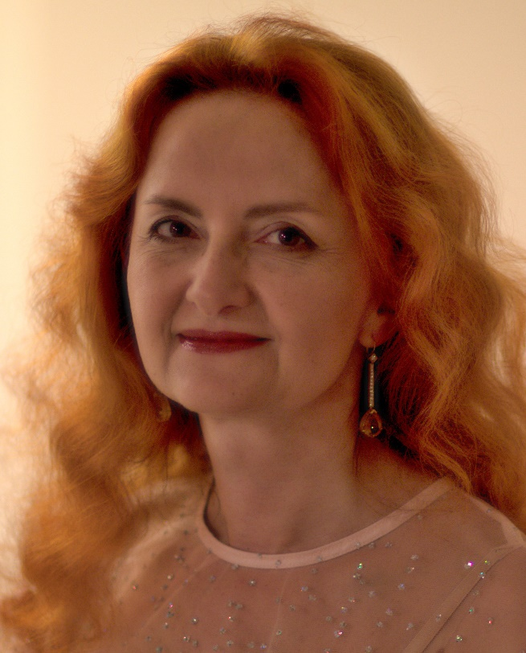
MUDr. Ilona Divácká, MBA graduated from the 3rd Faculty of Medicine, Charles University, Prague general and preventive medicine. She has attestation in psychiatry I. st. (1999), II.st. (2001), functional specialization in systematic psychotherapy (2003) and Proficiency in Gerontopsychiatry (2011). In 2002 she finished the MBA. Since 2004 she has been running a psychiatric clinic with a focus on gerontopsychiatric patients. 2004-2015 she worked as a consultant psychiatrist in the Home for the Elderly in Prague 10 - Malešice. Since 2016 she has been an expert in the field gerontopsychiatry. Contact details: Psychiatric clinic, Prague 10.

Depression and Mood Swings Leading to Suicidal Behavior in the older persons

Suicide among older persons differs in many ways from suicide in younger age. The presentation focuses on specific clinical picture of depression in older age and organic depression, factors leading to depresssion and treatment options. It also includes suicide prevalence, suicide risk factors, warning signs, association between somatic illnesses and suicide, passive suicide. Certain recommendations for primary care physicians are listed in the presentation.
Key words: suicidal behaviour – suicide - elderly

