Doc. PhDr. Ludmila Čírtková, CSc., Dr. h. c.
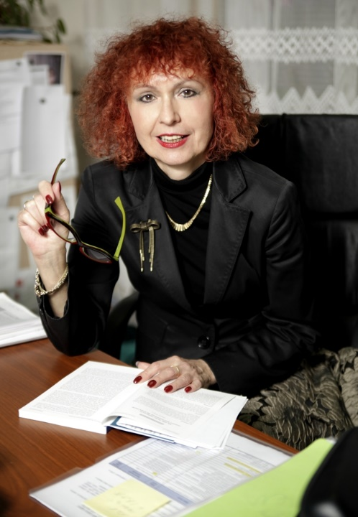
Forensic psychologist, academic staff, expert witness
As a forensic psychologist, she cooperates on the clarification and investigation of a crime. She lectures externally forensic psychology at the Law Faculty of Charles University. She is an academic worker at the Faculty of Biomedical Engineering of the Czech Technical University in Prague where she focuses on issues of radicalization and extreme violence. Until last year she worked as Vice-Rector of the Police Academy of the Czech Republic in Prague. For a long time she has been involved in a problematics of domestic violence and victimology.
In her spare time she works as a volunteer in the White Circle of Safety, which helps victims of a crime. As a psychologist she works in a counseling center for victims of crime. She has published several books, the last one is called Viktimologie pro forensic practice.
She graduated in a psychology at the Faculty of Arts of Charles University.
Title of the post: Victim and Perpetrator Typology
The post will offer an insight into current approaches to typologies. What practical meaning have the typologies of offenders and victims to EAN prevention? To this question the author is looking for an answer. It will focus in particular on “Domestic Elder Abuse and Neglect '. A variety of close-by offender profiles will be illustrated at two domestic cases. Diversity of psychological profiles of the offenders also the variety of forms of EAN places considerable demands on detection and timely intervention cases EAN. Many risk factors are not visible in time. To break the hiding of this negative phenomenon is the first step in preventing or control it. In the future it is necessary to improve public awareness, but also availability of assistance to victims.

