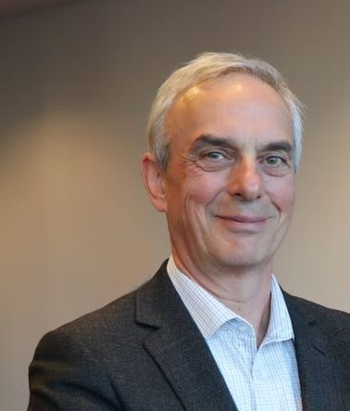
Professor Simon Biggs
Simon has worked as a Community Psychologist and for the UK Social Work Education Council before becoming a Professor of Social Gerontology in 2000. He was Director of the Institute of Gerontology, King’s College London UK. Since Sept 2010, he has worked in Australia at the School of Social & Political Sciences, Melbourne University and at BSL, a local social justice charity. He has participated in EU, UK, Australian and Canadian Government briefings on population ageing, dignity in later life and on elder protection. From 2008 to 2014 he was a founding member of the World Economic Forum’s Global Agenda Council on Ageing Societies. Simon is a Fellow of the British Academy of Social Sciences. He has researched elder mistreatment, age friendliness, older workers, dementia and regulation of age care and his most recent books include ‘Generational Intelligence’ ( with Lowenstein) and ‘Negotiating Ageing’ both published by Routledge.

Elder Abuse, Ageism and Human Rights
Elder abuse, ageism and human rights have different but interconnected narratives. Each has been shaped to address specific levels of interaction, such as interpersonal engagement, social attitudes and the relationship between individuals and the state. They exist within a context of contemporary discourses on later life, including an increased commodification of the lifecourse and privileging of work related activity as a means of social inclusion. These may reduce the chances of empathic understanding to emerge between generations. Recent research on attitudes to dementia shows that it generates its own forms of social exclusion, raising the question of whether elder mistreatment actively generates situations that exclude carers and people living with abuse. The uses of regulation will be explored as both a means of shaping social space and behaviour and as a practical point where the three narratives intersect.

Theoretical development in Elder Abuse and Neglect.
Simon will examine the need for further study of the permessors for elder mistreatment, the interconnection between different levels of analysis and seeking the links between conceptual understanding and practical consequences.

