Sara Alon PhD, MSW
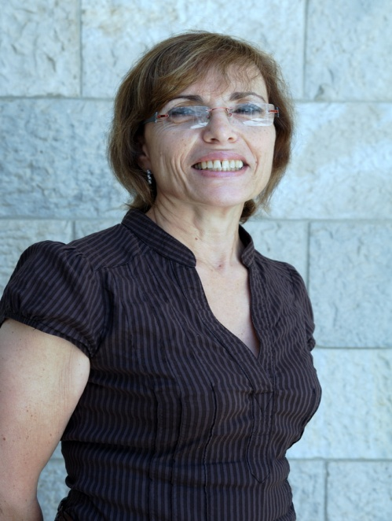
Sara Alon PhD, MSW, is a Lecturer and researcher at the School of Social Work, Tel Aviv University. Served till 1/11/19 as a Senior Program Director at JDC- ESHEL (The Association for Planning and Development of Services for the Aged in Israel). 2017-2019 was the manager of a pilot program for the Integrated Care in the Community (responsible for maintaining constant contact with policy makers in the government ministries that participate in the program; participates at the regional and local level steering committees that accompany the program, development of the professionals employed in the program). She also wrote a manual on establishing and operating Integrated Care Units in the Community.
2000-2016 served as the manager of the Elder abuse & Neglect Program at JDC-ESHEL. In this position, she was involved in development of knowledge in the field of elders at risk in general and elder abuse and neglect in particular. She developed and implemented models for interventions for prevention and treatment in the field of elder abuse which were accompanied by evaluation studies. At the same time, she developed training programs for professionals serving older adults. In addition, she has written and published training materials, manuals, 2 books and articles on the subject of elders at risk.
In her background she served as the head of a Welfare Department at a Municipality (1984-1996).
Her main field of research include: elders at risk (elder abuse; Dementia); risk assessment for elder abuse; professionals’ encounters with elder abuse and evaluation of training programs and their impact on professionals' work.

