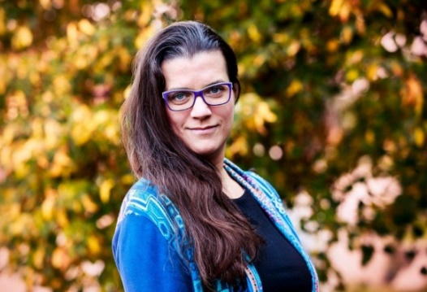
Mgr. Lucie Vidovićová, Ph.D.
Mgr. Lucie Vidovićová, Ph.D., is a sociologist and a researcher. She has been worked in sociology of aging, sociology of family and sociology of generations for the long time. She is involved in research projects for national and international institutions and also works as a consultant on a number of implementation projects.
Abstract: Seniors and digital gap - these technologies are not for old ?! Bringing seniors out of the digital margin
Seniors are referred to as a group of digital immigrants who, unlike digital natives, were not born with a smartphone in their hands, and enter the land of promised technology as foreigners and sometimes even as uninvited guests. The consequence is a deep technological and digital gap that either pushes seniors to the margins of the society and / or leaves them at odds with hoax predators. But whose side is the fault? You can't teach an old dog new pieces, or "these technologies aren't for the old", because seniors don't really need technology to live? And is it not that some technological backwardness somehow belongs to old age? And what does all this mean for carers and social and health care providers today and tomorrow?
The introductory speech of the interactive workshop will focus on the spectrum of digital gap‘sources, and together we will look for blind spots and possible ways to bridge the depths of technological ageism.
The workshop is co-organized by the Institute of Gerontology, CIIRC CTU and the Faculty of Social Studies within the “Humor” project (TA ČR project TL02000362 - Using a humanoid robot for active aging).

