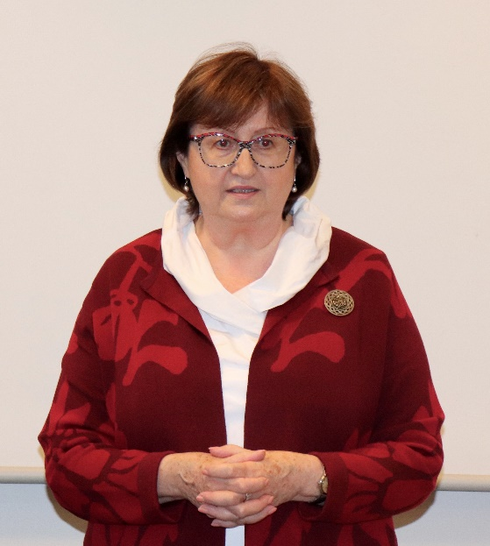
Mgr. Petra Vitoušová
Petra Vitoušová established Bílý kruh bezpečí („White Circle of Safety“), non-governmental organization helping victims of crime in the Czech Republic. She completed a number of internships abroad and professional training focused on helping victims of crime and domestic violence. She is engaged in consulting, teaching and pedagogical activities. She helped to draft and enforce a law to protect against domestic violence and to put new legislation into practice. In 1996, she was the first member of the Ashoka International Association in the Czech Republic to be elected for her activities for victims of crime: Innovators for the Public and at the World Economic Forum, she was named Social Innovator of the Year 2002.

Detection of elder abuse and limits of help
The contribution draws on the outpatient experience of Bílý kruh bezpečí (White Circle of Safety) and the database of the Victim Assistance Line. It focuses on risk factors in partner violence of the elderly, offers suggestions on ways to improve the detection of abuse of the elderly and also reminds the limits of the possibilities of helping the abused.

